## **Module 1: Lab 2, Demonstration of Assignment 2**

Saurabh Kale

IFT 458/554: Middleware Programming & Database Security

Dinesh Sthapit

Aug 25th, 2023

1. Error



On loading the default page it gives error as there is no route for ‘/’

Now the new route is ‘/StudentForm’ we should type the following to get the page.

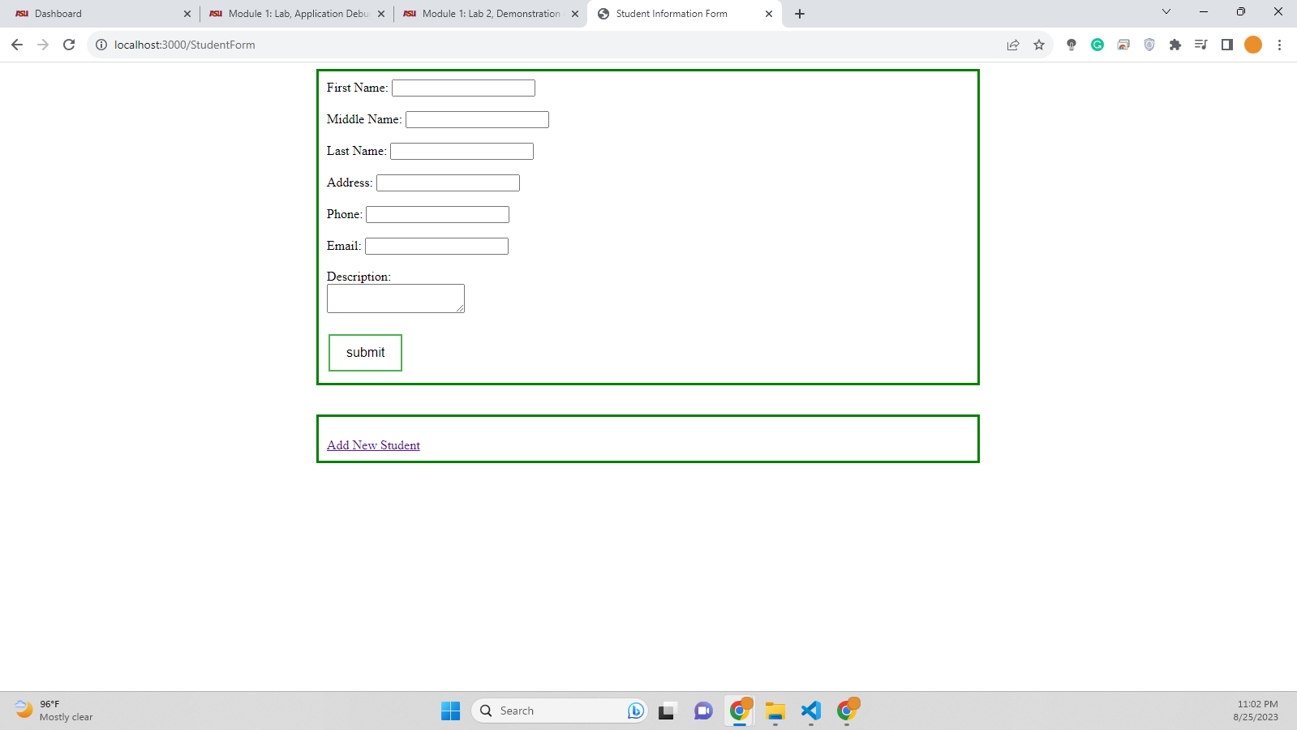



On clicking the submit button it throws error for ‘Cannot POST /’

This error is thrown as the submit button in index.ejs requests a POST method with route ‘/’ and there is no post method in app.js with that route. To handle this we have to change -  
<form action="/" method="POST">   
to   
<form action="/StudentData" method="POST">

And in app.js we will change the following code-  
app.post('/StudentData', (req, res) => {

//Add the submitted student data to our data store

students.push(req.body);

//Redirect back to the form

res.redirect('/');

});

To   
  
app.post('/StudentData', (req, res) => {

//Add the submitted student data to our data store

students.push(req.body);

//Redirect back to the form

res.redirect('/StudentForm');

});

Where res.redirect will redirect to new path and it won’t throw error in old path.

Or we can have a better solution if we know that /StudentForm is the default route we wanna show then we can add a default route in app.js and redirect it to /StudentForm  
  
app.get('/', (req,res)=>{

res.redirect('/StudentForm');

})

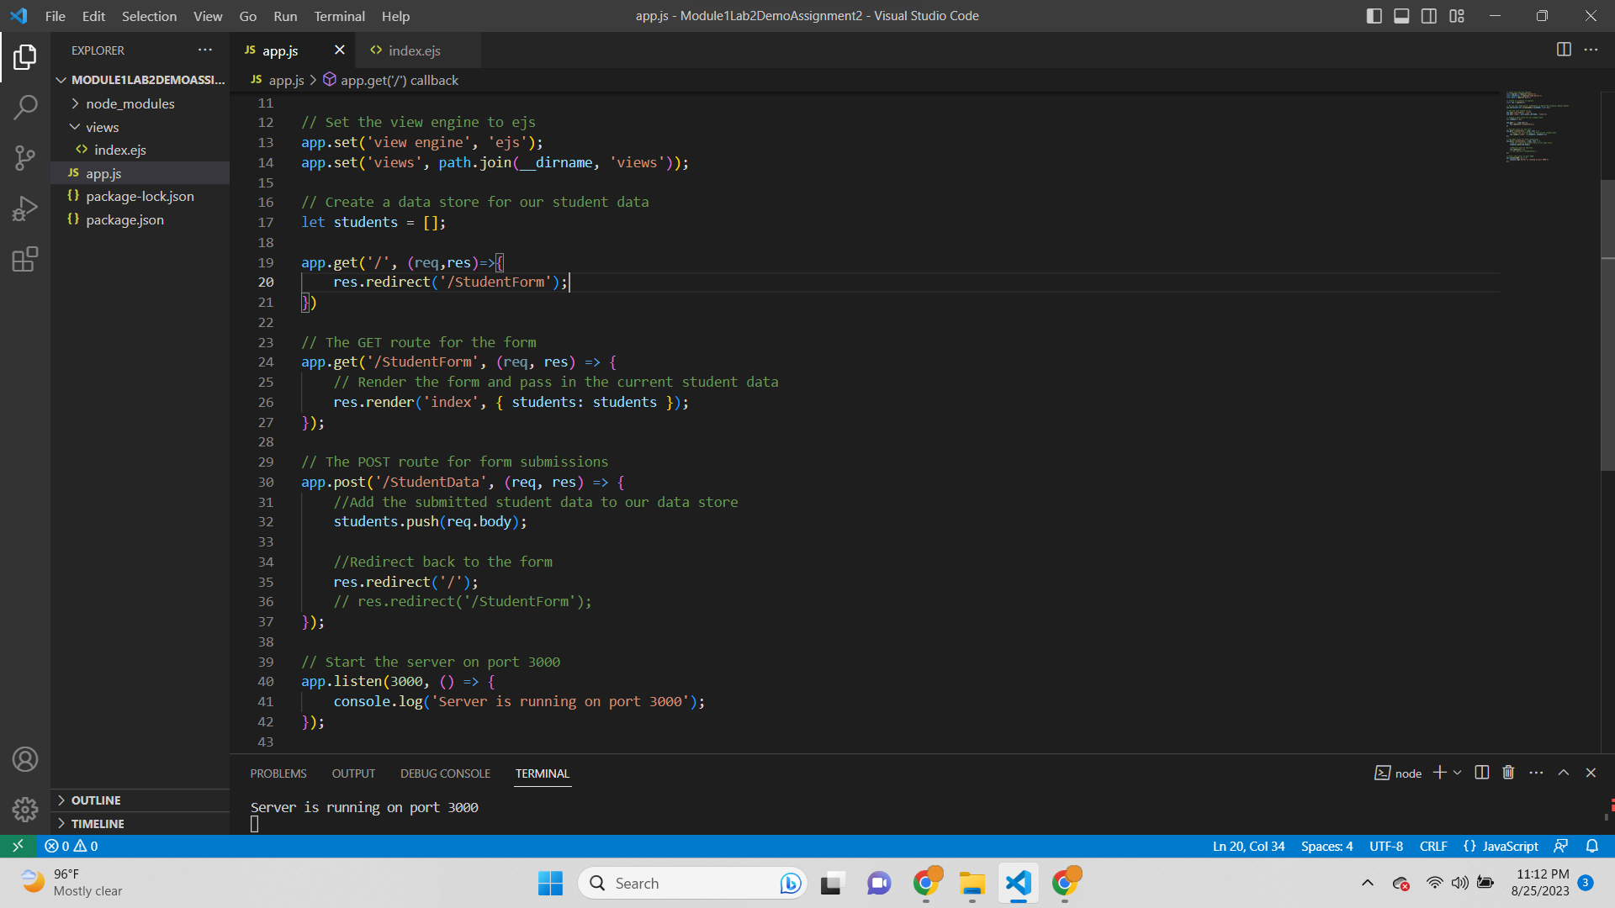

This way we don’t have to change the redirect in post method and everything works fine.

Code Working Proof-  
  
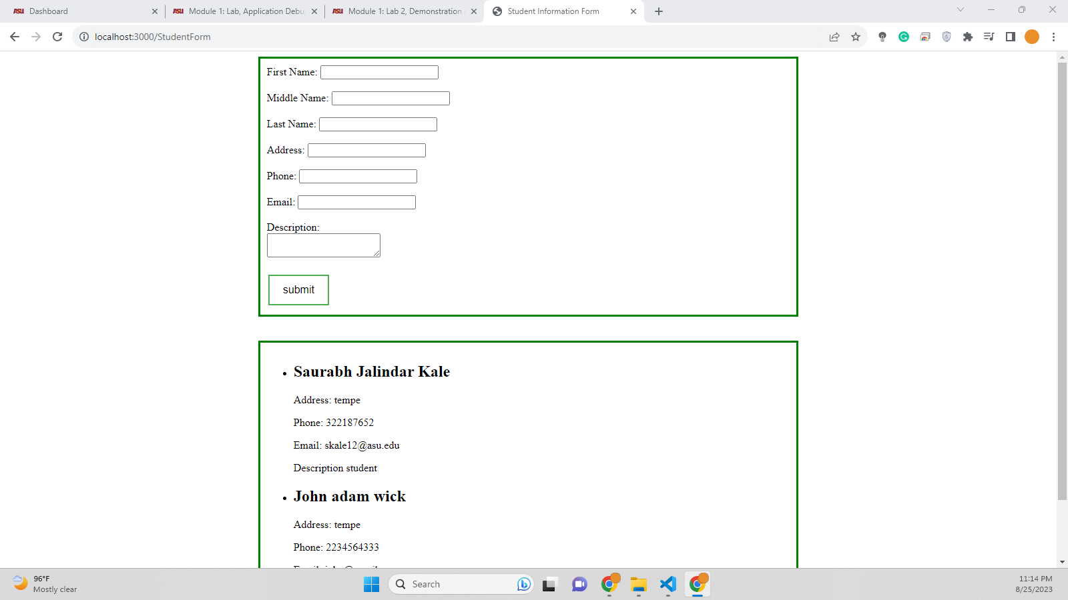

Output with 2 entries-  
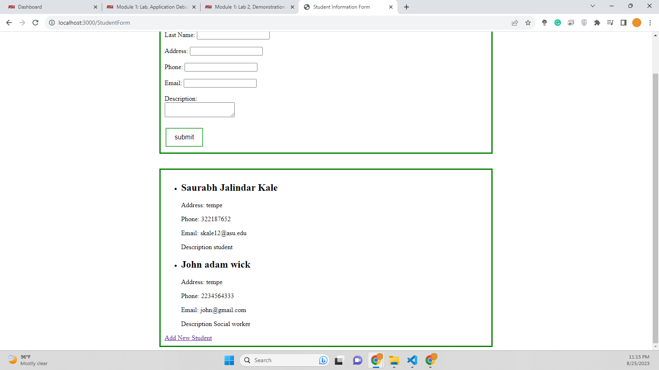

As we have added the default route and redirected it to /StudentForm so even if we go to ‘<http://localhost:3000/>’ link we will be redirected to <http://localhost:3000/StudentForm>

Screenshot of link typed and before pressing enter-

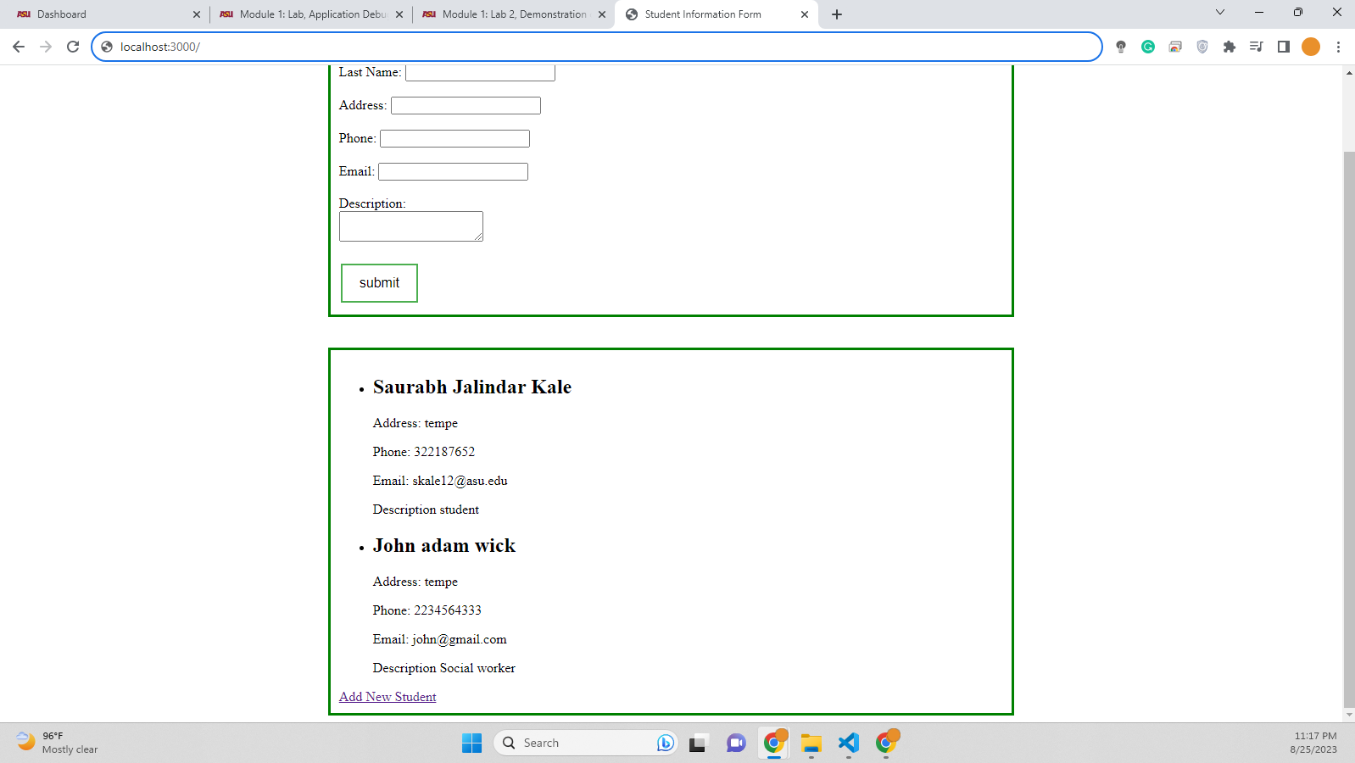

Screenshot of link typed and after pressing enter-  
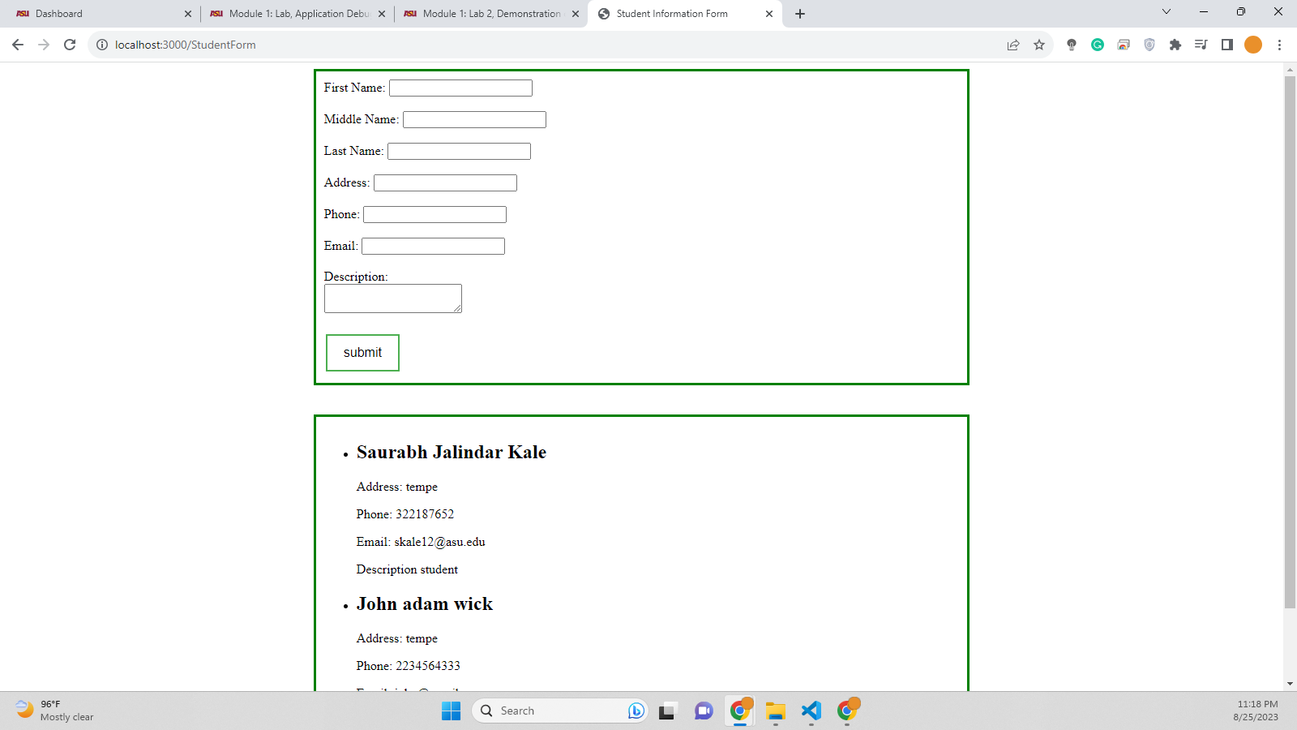

Non-default port is 3000 which is often used ofr web development particularly for running web applications. The routes we will choose for testing are -

1. ‘/’
2. ‘/StudentForm’
3. ‘/StudentData’
4. Default route (‘/’)

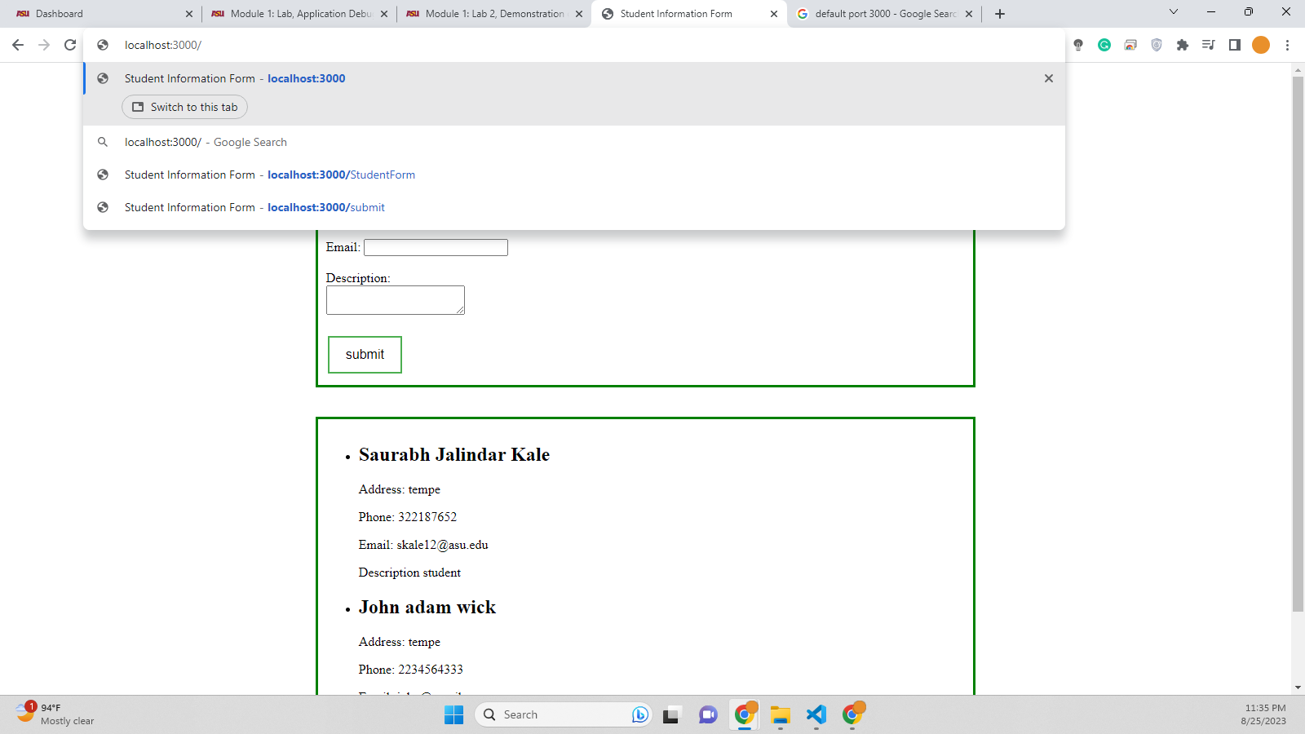

On entering default route and pressing enter it will redirect to ‘/StudentForm’ as we have added a route to redirect it and handle that route.  
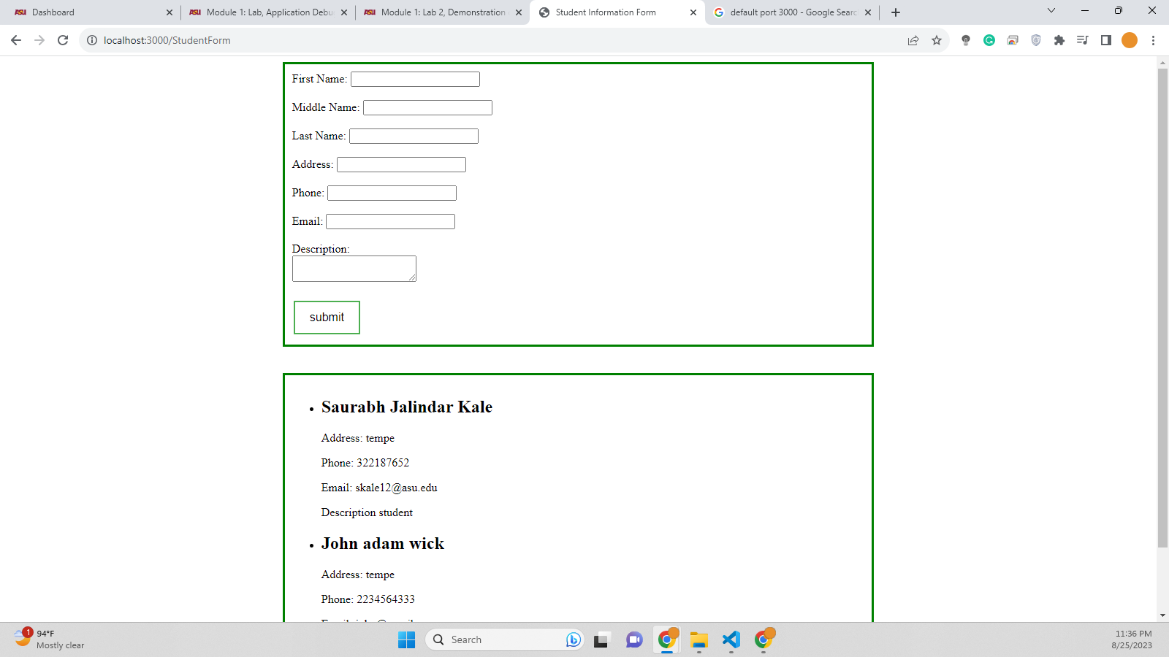

1. ‘/StudentForm’ route

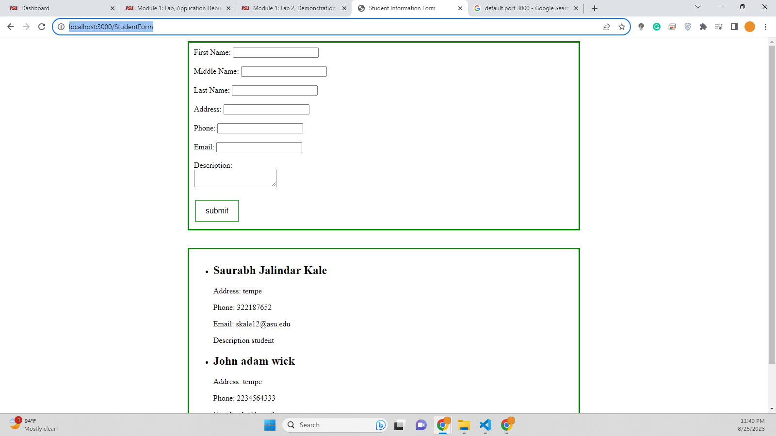

This is the main route where there is form. By default even default route redirects to this page. On entering <http://localhost:3000/StudentForm> and hitting enter it works perfectly and displays index.ejs

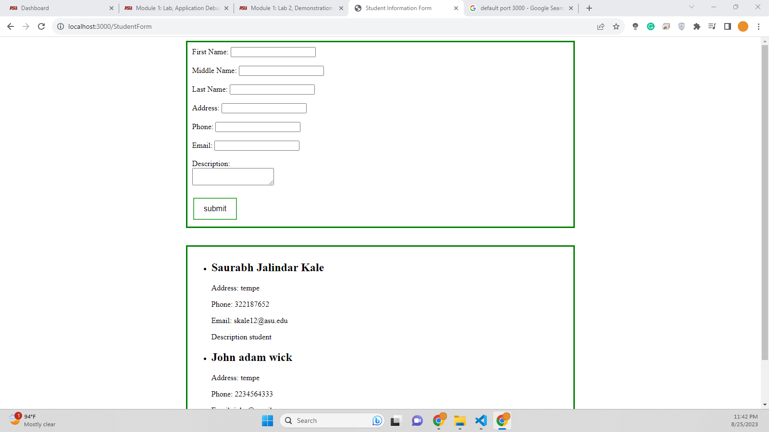

1. ‘/StudentData’

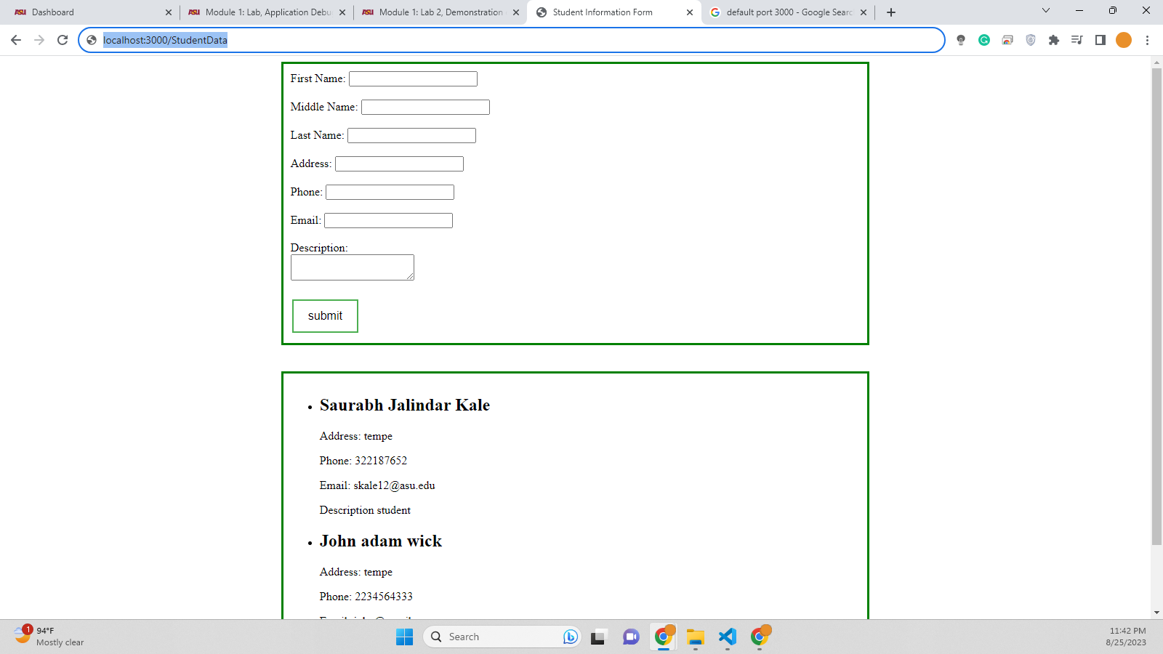

On entering ‘<http://localhost:3000/StudentData>’ and pressing enter it throws an error message saying   
‘Cannot GET /StudentData’ which is expected as we are trying a get method whereas ‘/StudentData’ route is defined for POST method and there is no GET method route for ‘/StudentData’ in our application.



* **Suggestions for improving the application based on your testing**

My suggestion for improving the applications based on testing would be to handle all other routes to a default route like home page or an error page rather than showing ‘cannot GET /StudentData’